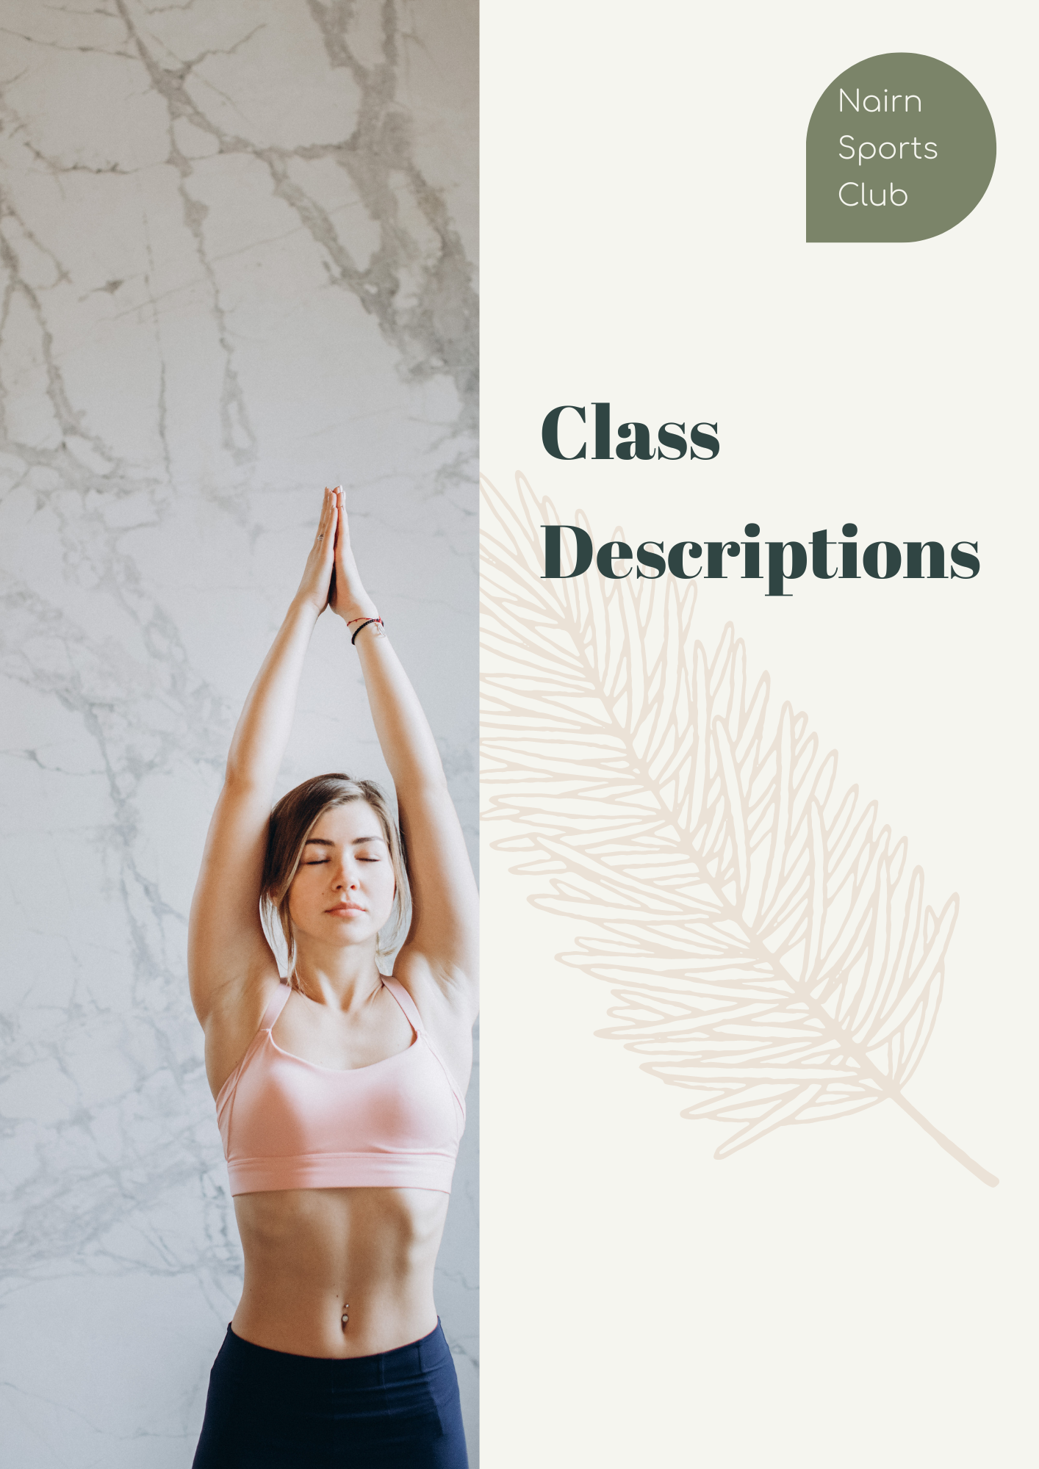
Class Descriptions
Fit4Life
This is a class tailored to the older adult. It is a low impact workout and is suitable for all fitness levels.

ZUMBA
Zumba is a dance-based work-out to upbeat Latin and international music that just makes you want to move to the rhythm of the beat!

ENERGY BOOST
Low impact workout suitable for all fitness levels. Works on improving posture, building strength and gaining flexibility leaving you feeling more energised. Total body workout, working on arms, legs, bum and stomach.

Yoga
Yoga encourages you to focus on your body, mind and breath. Regular practice reduces stress and increases your strength, flexibility, coordination and balance. In this class, we will be working on a mat (standing, seated, lying and on all fours) with optional extra props such as a yoga strap or blocks. Every session includes a short period of guided relaxation, and simple yet effective breathing exercises will be taught regularly. This class is suitable for all levels of experience, including beginners.

SPIN CLASS
Spinning takes part on a bike focusing on endurance, strength, intervals, high intensity and recovery. Set in a dim lit room you will get lost in the music and forget how hard you are working!!

C45
This time related interval circuit class. 15 different exercises working the whole muscular range and extending Cardio Vascular fitness levels throughout.

TABATA, ABS & STRETCHING
High or low impact timing related online exercise class. 5 individual exercises targeting different muscle groups each of which you will complete 8 times for 20 seconds best effort interspersed with 10 second rest periods.
The 20 Minute Core section will be followed by 10 Minutes of deep stretching with the focus changing every session.

Bar & Bike
Bar &Bike - suitable for all from Novice to Experienced user. Focus on correct Bar Bells & Bike techniques throughout. Perfect balance of spinning & weighted bar exercises.
BEGINNERS PILATES
Bring healing to your body and peace to your mind. Aimed at strengthening muscles while improving posture alignment and flexibility.

BARRE
Barre class is low impact and suitable for all fitness levels, toning body weight workout to fine tune your muscles, squats, lunges and sit ups.

Female Only Gym Sessions
Female Only Gym Sessions. Learn the basics with circuit sessions. Full Body Workout, 1-1 support, burn calories and be shown the correct techniques using Cardio, Fixed and Free Weights. (Limited frequency).

Stable & Strong
This is a slower paced class for the older adult who wishes to improve balance strengthening muscles and maintaining bone strength.

